|  |
| --- |
| Team 14 |
|  |

# Memorandum

To: IT Director

From: Team 14

Date: February 18, 2023

Subject: Protection for Linux Servers

In response to your request to protect Linux servers, we have implemented host-based firewalls on each Linux server that affects the control of inbound packets to only permit those that are expected.

We accomplished this task using Iptables, a host-based firewall solution. Below we have included screenshots of each Linux server demonstrating the implementation of Iptables.

Fedora Server

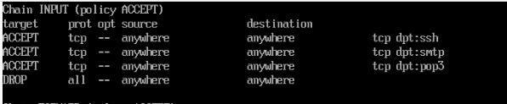

CentOS Server

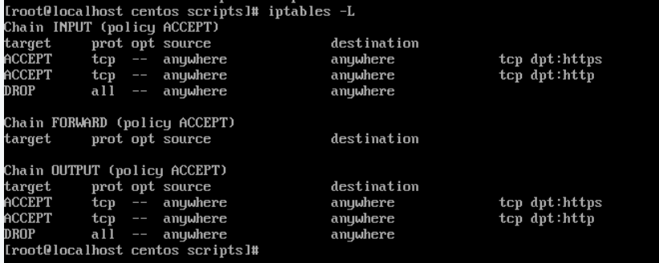

Debian Server



Ubuntu Workstation

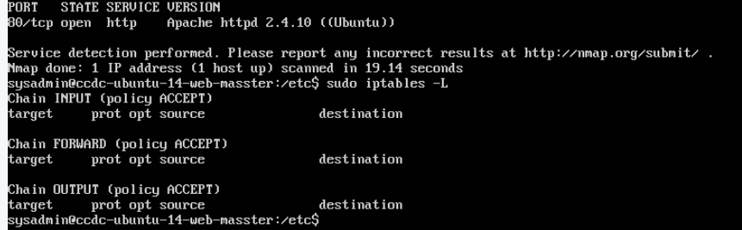

Splunk Server

